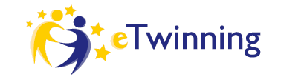

NEW YEAR CARDS EXCHANGE

“New Year cards exchange” is a project about New Year cards. Each school will make cards (pupils will write Happy New Year in their mother tongue) and will send them during the Christmas holidays, as many cards as involved schools.

SUBJECTS: English, Italian, Art.

AGE OF STUDENTS: 5-10

LANGUAGE: English and Italian.

PARTNER: Croatia, France, Slovena, Romania, Greece and Turkey.

TOOLS: twin space and art.

OBJECTIVES:
1. To increase interest in foreign languages and cultures.
2. To improve language skills.
3. To increase students’ creativity.
4. To learn words in foreign languages.
5. To learn about another cultures and festivals.

OUTCOMES: intercultural learning and knowledge of other cultures and general information regarding pupils who live in different countries will be enhanced.

